Lab Assignment 3-2 Shell Scripts Linux+ and LPIC-1
Show the complete script (or commands) and the resulting output for each question.

- Modify the following script to insert descriptions of each of the commands.
#!/bin/bash
# This is the first example script
date
w
ls –l
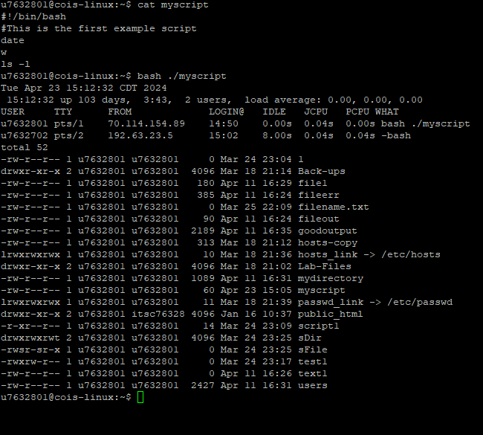

- Write a script which will read the name of a directory and then create it as a sub directory in your home directory.
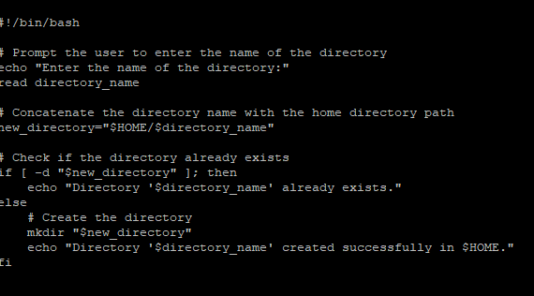

- Complete the following scrpt:

#!/bin/bash
# This script lets the user choose to view the date, current users and processes, or the contents of the home directory
# Enter a choice
echo -e "What would you like to view:
Today's date --------------------------------> (d)
Current users and process -------------------> (u)
Contents of home directory ------------------> (h)
Enter choice d/u/h---------------------------> \c"

# Get the choice (complete this section)

# The decision construct to process the choice (complete this section)

# End of Script
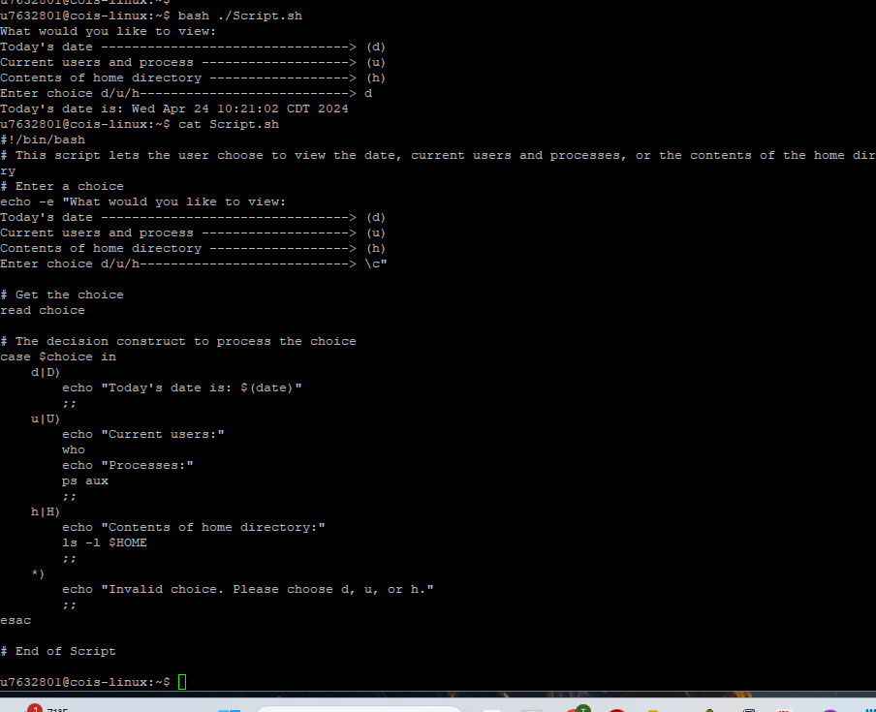

- Create a directory called Files in your home directory. In the Files directory create five files: Name, Address, State, Zip, and Phone. You can use touch to create the files.
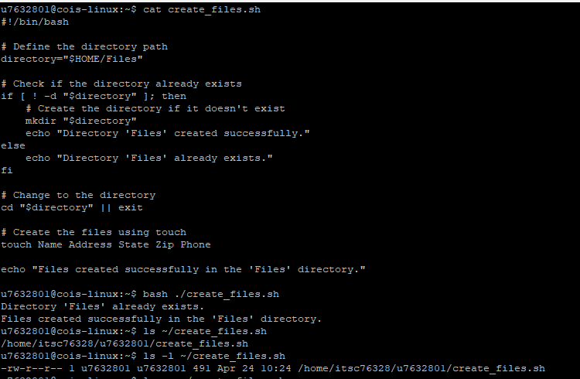

- Write a script file which will rename each of the files in directory Files (created in question 4) with a “.txt” extension. For example file Name will become Name.txt, etc.
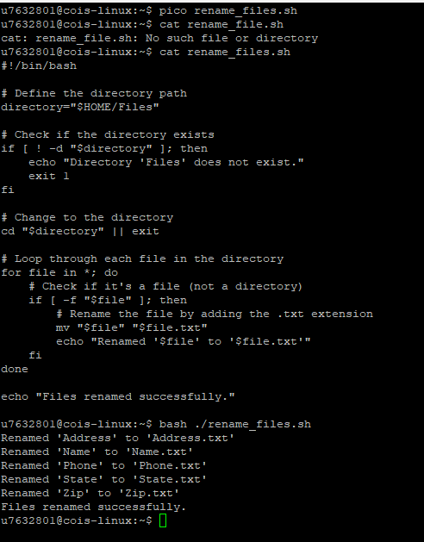

- Write a script called MakeFunction which creates a function named: CreateDir. The function when called should accept a new directory name as a command line argument and then create the new directory. Note: when executing MakeFunction used the dot command so that the function will be created in the login shell.
